Year 7 – Spreadsheet and modelling – The basics

Links to get video help with simple features and formulas of Excel:

http://www.teach-ict.com/software/excel/excel.htm

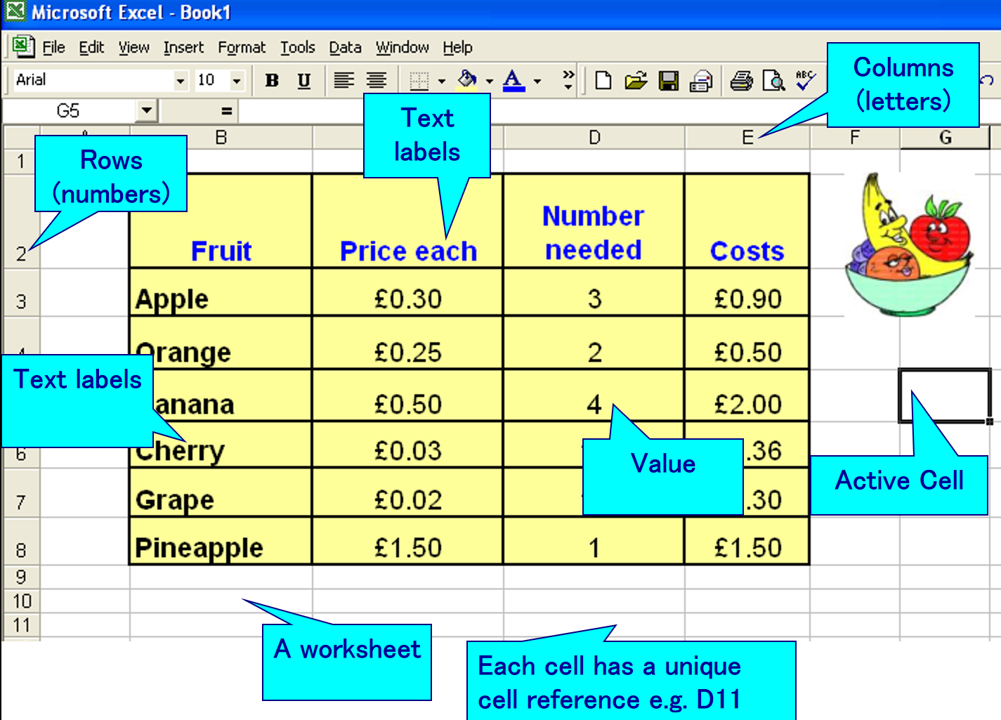
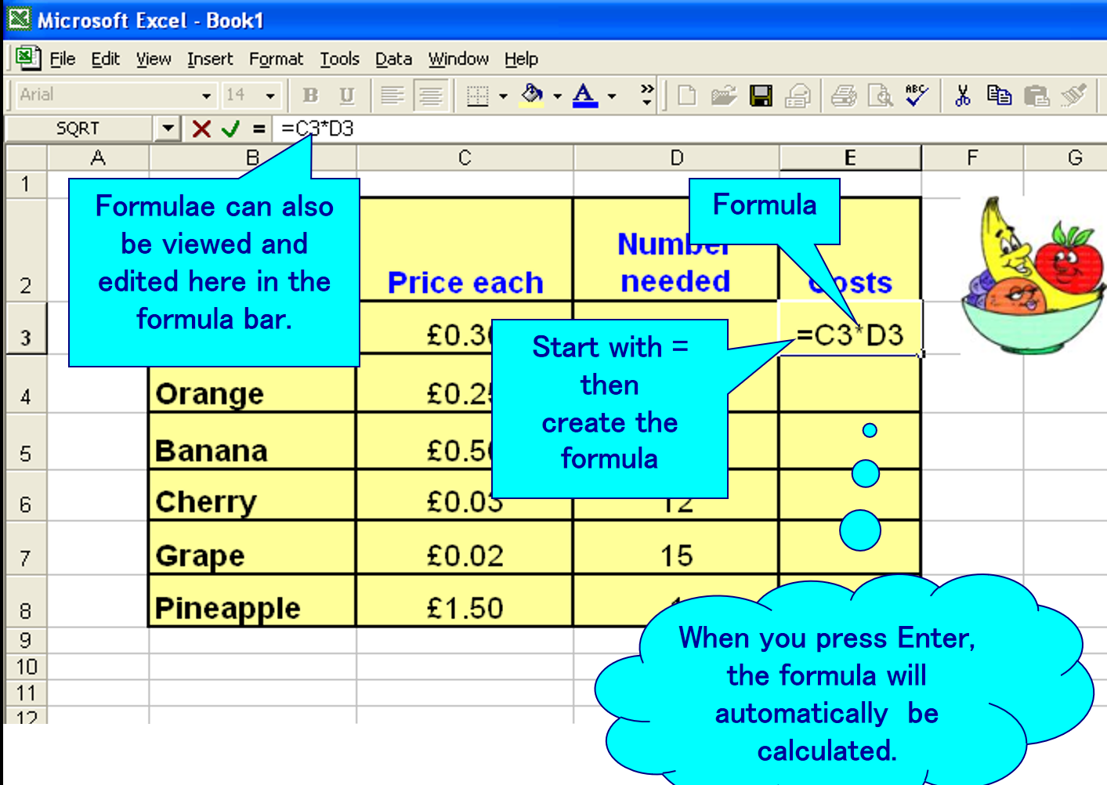

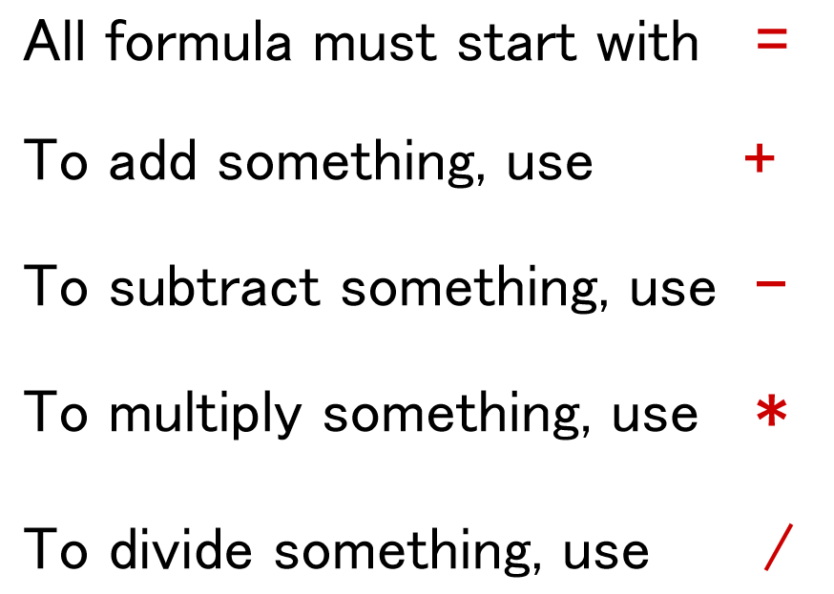

RECAP OF SPREADSHEET FEATURES

1. Label the different parts of the spreadsheet below with these key terms:

Worksheet | Value | Text Label | Active Cell
Row | Column | Formula | Cell Reference G5

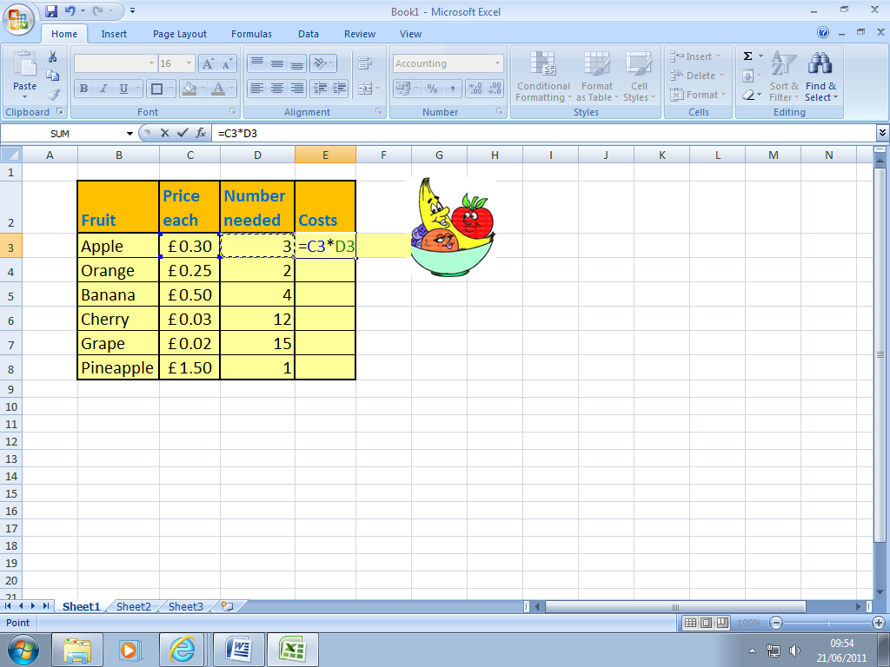

Complete the questions below to identify the symbols and formulas used:

2. What symbol must a formula always start with?

3. What symbol would you use to add two numbers together?

4. What symbol would you use to subtract a number?

5. What symbol would you use to multiply two numbers?

6. What symbol would you use to divide a number?

7. Write the formula to work out the cost of the bananas

8. Write the formula to work out the cost of the pineapple

Albus Bumblebore, the Headmaster, wants students to be able to buy small items of stationery during break and lunchtimes.

Albus knows that you are good at creating spreadsheets. He has asked you to set up a spreadsheet to keep track of the money.

You need to plan how to set out your spreadsheet. Think of things which might be for sale in the shop and how much they might sell for (you don’t have to be completely accurate).

Fill in the table below with 9 other items needed for your shopping of stationery, remember to include the correct formulas (example provided in row 5):

 | A | B | C | D
1
2
3
4 | ITEM | COST | No.SOLD | TOTAL COST
5 | Pencil | £0.99 | 20 | =B5 * C5
6
7
8
9
10
11 |  |  | TOTAL
12 |  |  | MIN
13 |  |  | MAX
14 |  |  | AVERAGE

Formula and Functions to learn and include above:

Basic Formula and functions :

=B5*C5 – Calculate total cost for each item.
=SUM(D5:D10) - Calculates the total cost – D11.
=MIN(D5:D10) – Calculates the lowest total cost – D1.
=MAX(D5:D10) – Calculates the highest total cost – D13.
=AVERAGE(D5:D10) – Calculates the average total cost – D14.

Now you can design how your spreadsheet will look in excel. In the box below, sketch out your layout.
Remember to show:
- Where the title will go (Shopping List)
- Where the table will go
- Where an image will go

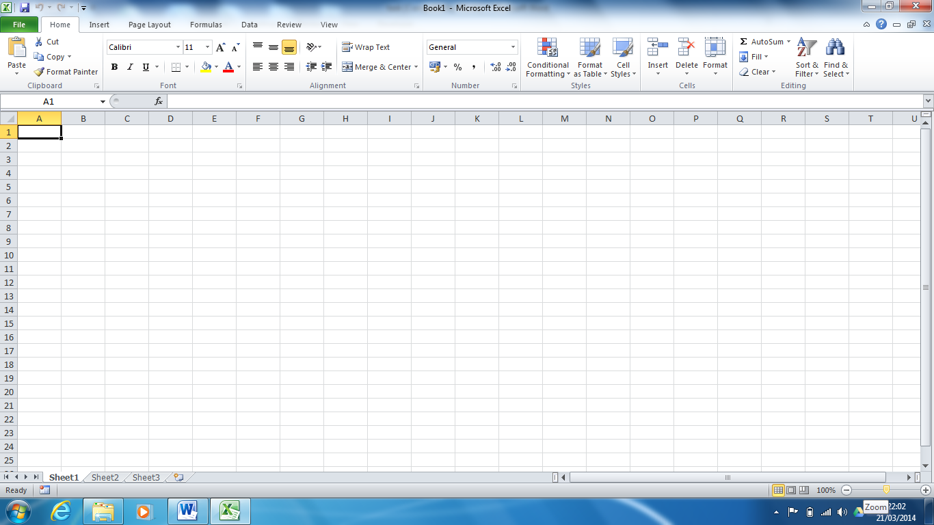

Once you have designed your spreadsheet why not try and create it in Excel if you have got this software.

Other skills in Excel needed for the “Spreadsheet and modelling” unit:

Sorting data in alphabetical order?
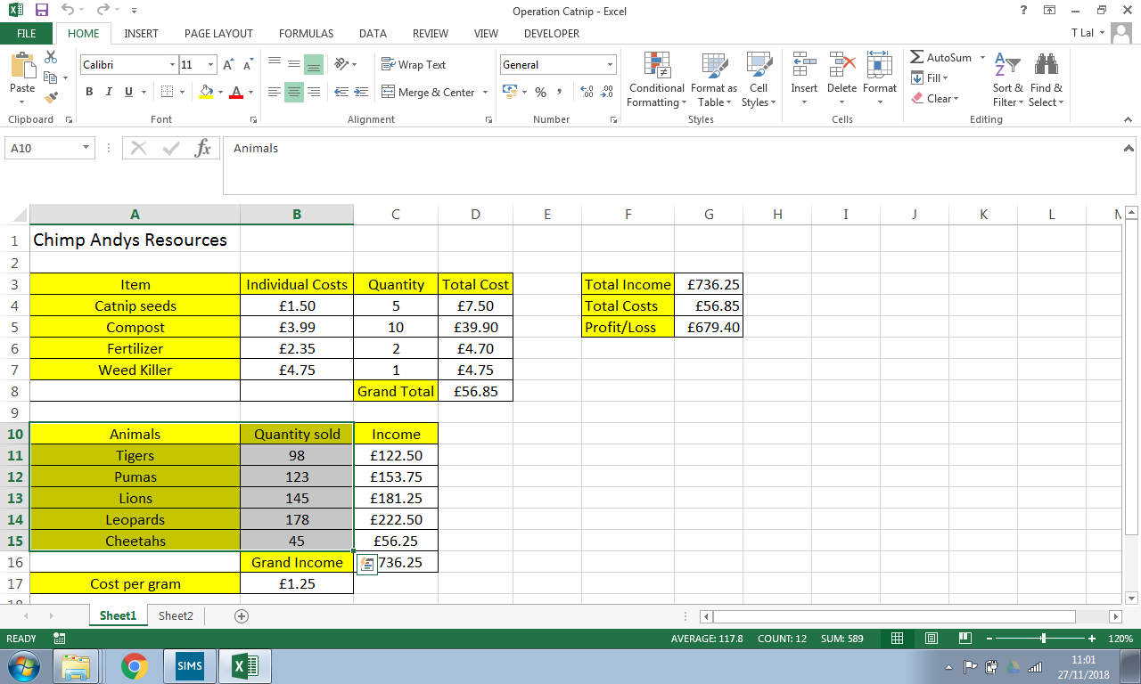
Highlight the data that you would like to sort.
Click on Data > Sort
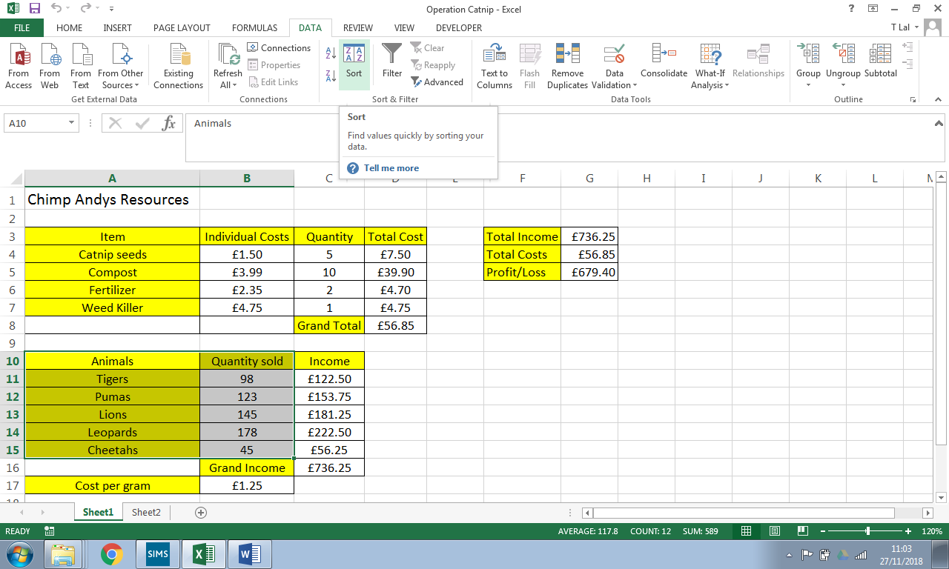
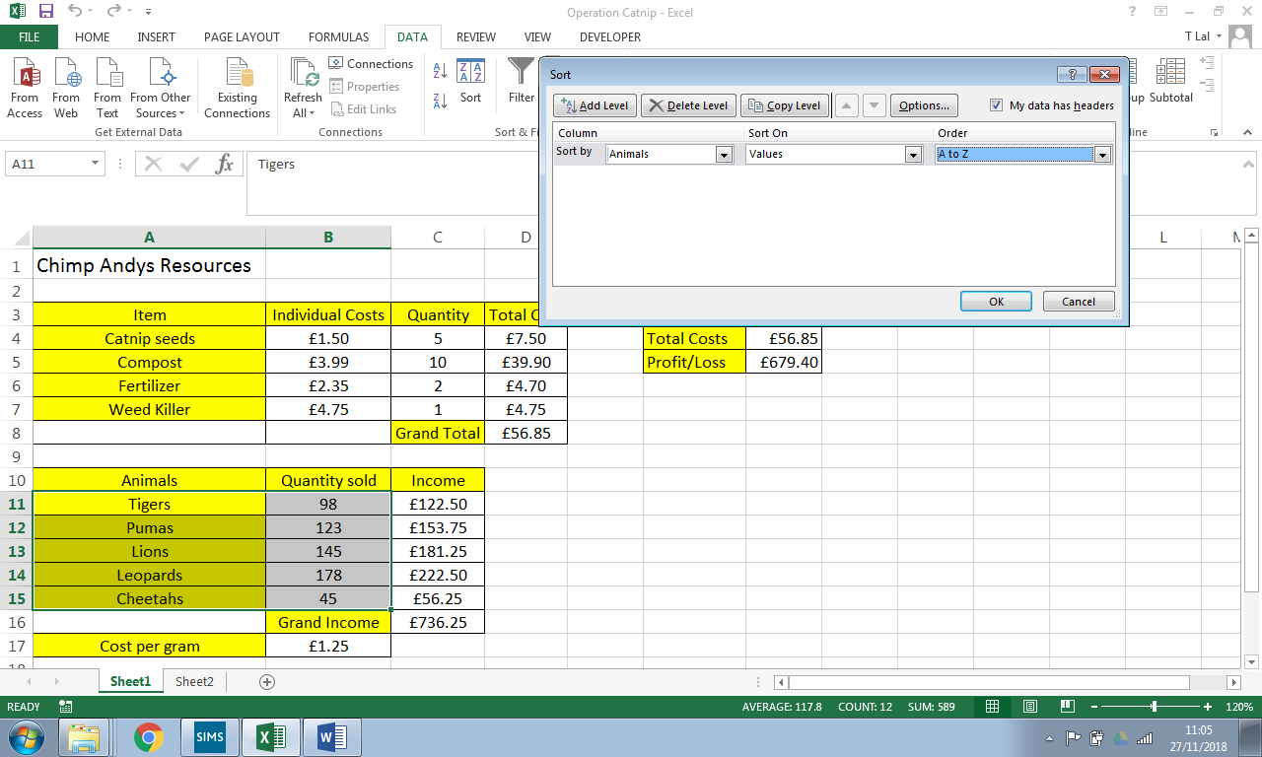
Select animals and A-Z AND PRESS OK.

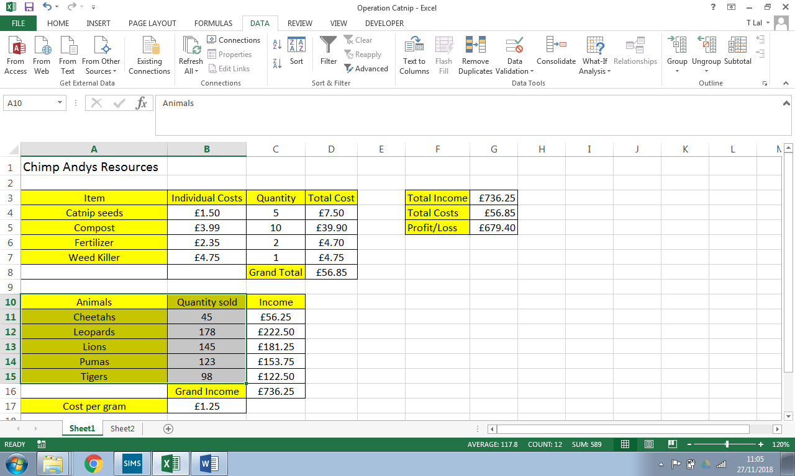
Look they are all sorted in alphabetical order

What is ascending order? (research and write a definition below)

Creating a chart:

To create a chart based on specific data:
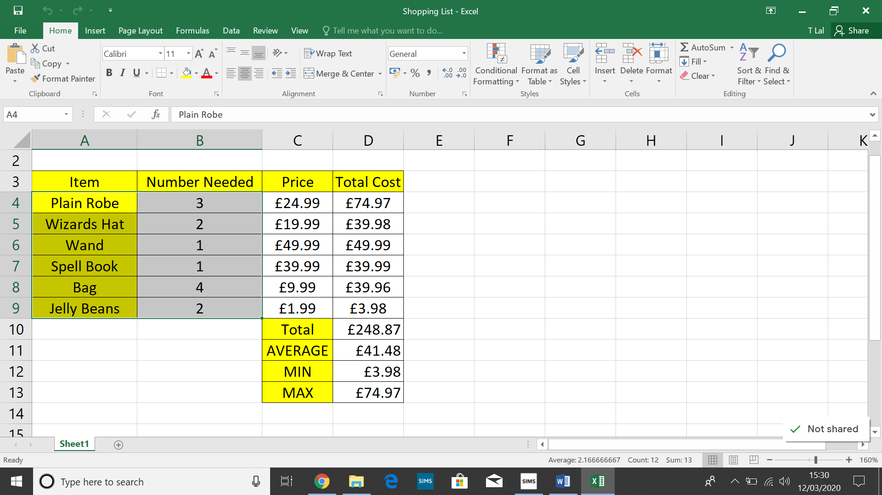
Highlight the data you would like to create a chart on. In this case the quantity of each item purchased.

(I have highlighted the items and number needed)

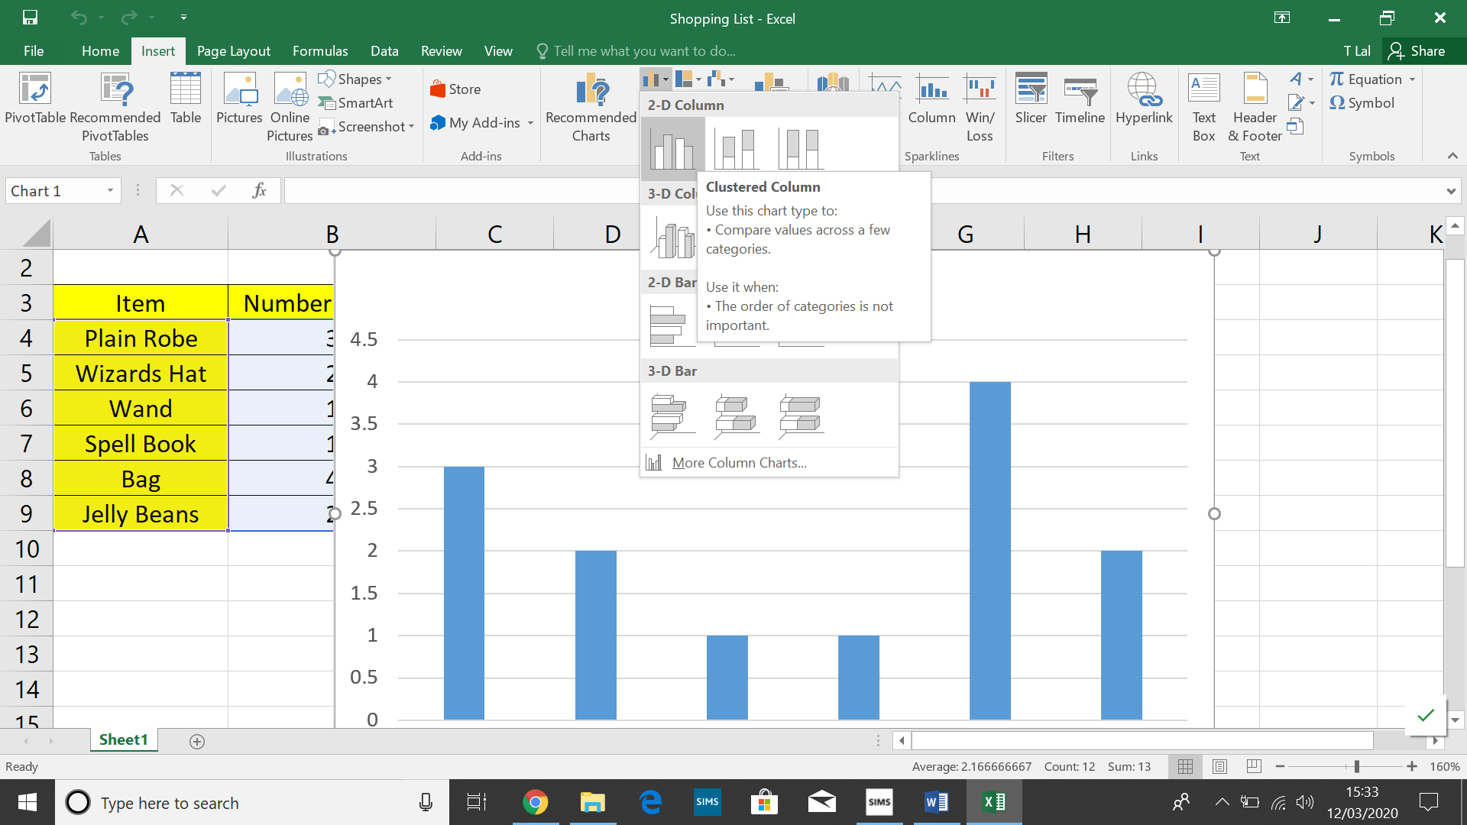
Click on INSERT > and select the chart you want to create😊

Maybe give it a try in excel by creating a chart on data in your spreadsheet??

Questions to answer:

What is a spreadsheet?

What is a cell?
Give an example of a cell reference?

What is a text label?

What is value?

What is a formula?

What does a formula start with?

What symbol would you use to add two numbers together?

What symbol would you use to subtract a number?

What symbol would you use to multiply two numbers?

What symbol would you use to divide a number?

Why do you use a formula?

What do the following formulas/functions do?

=SUM(D5:D10)

=MIN(D5:D10)

=MAX(D5:D10)

=AVERAGE(D5:D10)

Why would you create a chart?

